Kendall Townsend

CPSC 386

C. Siska

Final Project Design Report

My project is a game based off of the gameplay style of the game Binding of Isaac. In the game you can move across the map firing a projectile up, down, left, or right and move up, down, left, or right. The object of the game is to eliminate all enemies in the current room. When you eliminate all the enemies in the current room the game will spawn the same amount of enemies from the last level plus one. The objective of the game was to make a difficult enough game that can go on forever and just keep getting more and more difficult until the person loses.

The rules of my game are that you have to hit the enemy with your projectile while avoiding collision with their sprites and once you hit level 5 their projectiles. The game starts out really easy on level 1 with only one enemy. Each additional level will add an additional enemy to start the level with. Once you hit level 5 the enemies will start shooting projectiles, so along with having to avoid their sprites you will have to avoid their projectiles or you will lose. There is no actual end to the game the point of the game is to just get as far as you possibly can without getting eliminated by enemies. Eventually the game will get so difficult that it will most likely be impossible. The enemies have a timer in which it will randomly generate a number and that will be used to determine which direction to shoot the projectile. The map is made in such a way to help the enemy collision detection make them path randomly around the room. It does this by detecting whenever the enemy hit barrier on the map and then generates a number and based off that it will move in whatever direction it wants to. When the player eliminates enemies they have a chance to drop power-ups. One of the power-up drops is green and it increases the player’s speed, and the other is pink and it increases the player’s rate of fire. Any player can probably pick up this game all you need is a keyboard to play and the game difficulty on level one is ridiculously easy. It doesn’t actually start getting very hard until level five when the enemies start shooting projectiles. There is no actual win state for this game, the only point of it is to try and get further and further into the game. Although, if you get the rate of fire to 1 ms or lower you can create a constant stream of projectiles across the map and probably never get eliminated. The controls to play are the arrow keys, spacebar, and w, a, s, d. The arrow keys control the direction your sprite is moving, and w, a, s, d control the direction you are shooting your projectiles. You can either tap w, a, s, d to fire projectiles or hold down spacebar for continuous fire. The player sprite will continuously move and you just control the direction in which they go. Once your rate of fire gets to a certain point the only way to actually shoot them fast enough is to hold spacebar. The duration of the game is as long as you can stay alive which can be an indefinite amount of time but most likely somewhere around 5-10 minutes. You get 1 point each time you eliminate an enemy. The UI keeps track of what level you are currently on, your current score, and how many power-ups you have picked up for speed, and rate of fire.

My project had a lot of classes because there were a lot of things that had to interact with one another. There is the player class, and the block class which represents the enemy. They each needed their own projectile class so they have that, and I realized it would be easier to make a different class for each direction a bullet projectile can go in. This is because it just requires less variable modification and less chance for something to go wrong it’s also way easier for using RNG to determine which direction the AI shoots it for enemies. So they each have four classes for their projectiles up, down, left, right. They each needed their own projectiles because their projectiles can eliminate different things. Mainly enemy projectiles can only hurt the player, and player projectiles can only hurt enemies. Beyond that I have a barrier classes that has many different barrier because they have to be solid barriers they can’t be a bunch of smaller ones. They can’t be a bunch of smaller ones because it conflicts with the collision detection and it won’t know what to do and the player and the enemy AI will clip them outside of the game. There is last but not least the power-up class which is pretty minimal all it really does is generate a square of whatever color the power-up is. The major mechanics/logic is in the collision detection for the user and for the enemies. They both have similar logic for their respective bullets just making sure they hit the right things and disappear when hitting things like the barriers. For the enemies they move in straight lines until they hit barriers and then they will randomly move in any direction that isn’t blocked. Other than that it’s just the player movement logic and direction to shoot logic which is pretty straightforward besides making sure that there is a delay to control rate of fire.

So the first major thing that was implemented was the collision detection which took a very long time to get to work correctly. Like previously mentioned I originally made the barriers out of a bunch of really small sprites which caused problems with the collision detection. There isn’t much to show for that except that you can’t go through any barriers.

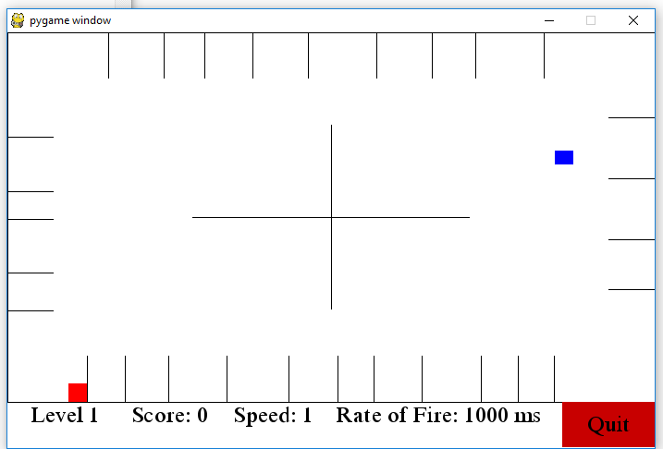

Next was the bullets and making sure they can’t go through objects. Here’s a screenshot with the rate of fire blasted up so you can see that they are stopping.

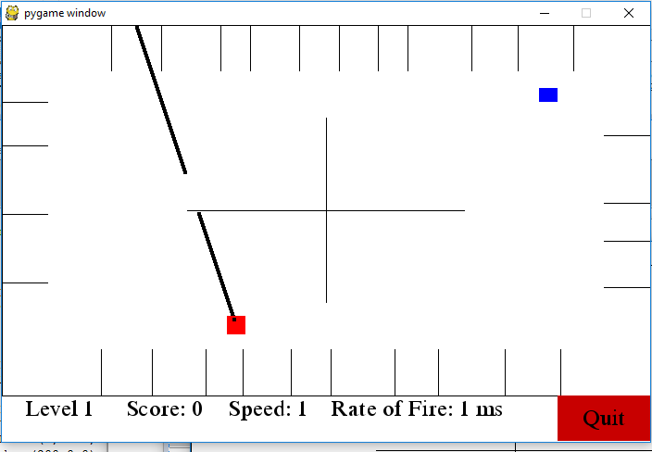

Next was getting the enemy to shoot projectiles.

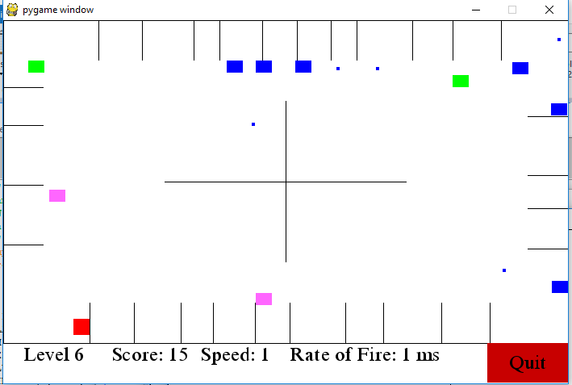

In the same screenshot you can see the power-up blocks. The pink ones increase the rate of fire, and the green one increase the speed.

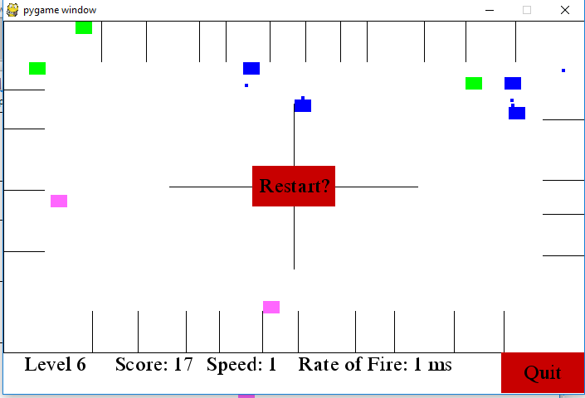

This screenshot shows what happens when you get hit/collide with an enemy and your character gets destroyed. When you hit restart it just brings you back to level 1 and resets your power-ups.

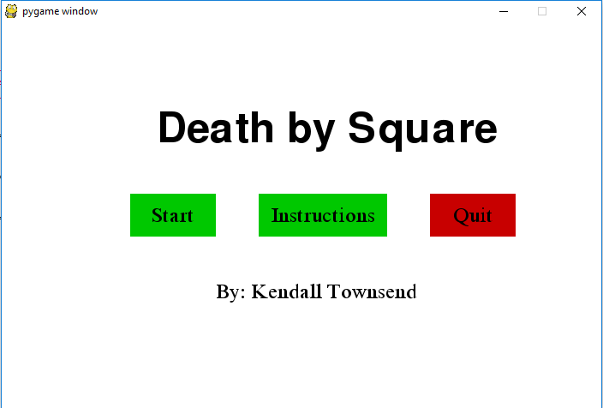

Minimalistic menu

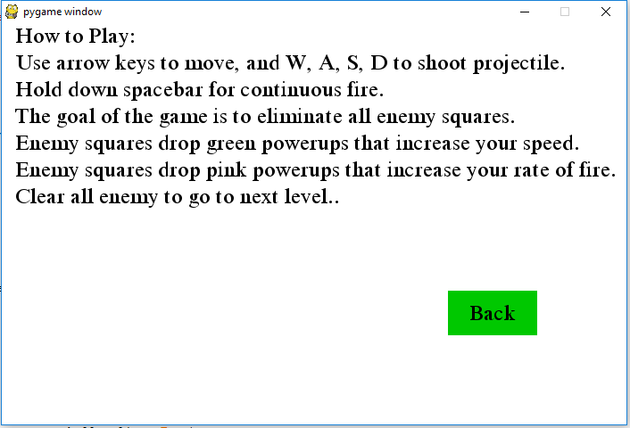

Minimal Instructions screen.

Bibliography

1. <https://www.youtube.com/channel/UCfzlCWGWYyIQ0aLC5w48gBQ>
2. https://pythonprogramming.net/pygame-python-3-part-1-intro/
   1. Used multiple videos from sentdex’s youtube channel, and from his webpage. He also has a pretty long tutorial on how to do a lot of things that I used.
3. <https://www.youtube.com/user/professorcraven/featured>
   1. http://programarcadegames.com/index.php?chapter=forward&lang=en#section_0.2
   2. Used multiple videos from professorcraven’s youtube channel. He also has a website with a bunch of tutorials of how to do different things.
4. Wouldn’t of gotten even close to finishing without either of these youtube channels they are very well done.

u push restart it just brings you back to the first level again.